EXPERIMENT 12

Prompt Evaluation, Comparison and Refinement using LLM Responses
Name | P Nishanth
Register Number | 192472294

AIM
To demonstrate the comparison of multiple prompts using evaluation criteria and refinement of the selected prompt.

PROCEDURE
- Select a text-generation task: explain Machine Learning.
- Create three prompts with different levels of detail.
- Display each prompt.
- List the evaluation criteria: relevance, accuracy, completeness, clarity, and format adherence.
- Prepare a refined prompt with clear instructions.
- Display the refined prompt and a sample final response.

PROGRAM
print("Prompt Evaluation, Comparison and Refinement")

prompts = [
"Explain Machine Learning.",
"Explain Machine Learning in simple words.",
"Explain Machine Learning with examples."
] for index, prompt in enumerate(prompts, start=1):
print("\nPrompt", index, ":", prompt)
print("\nEvaluation Criteria:") print("1. Relevance") print("2. Accuracy") print("3. Completeness") print("4. Clarity") print("5. Format Adherence")
refined_prompt = (
"Explain Machine Learning in simple words "
"with one real-world example."
)
print("\nRefined Best Prompt:") print(refined_prompt)

print("\nSample Final Output:")
print("Machine Learning is a branch of AI that enables") print("computers to learn from data and make predictions.") print("Example: Email spam detection.")

OUTPUT
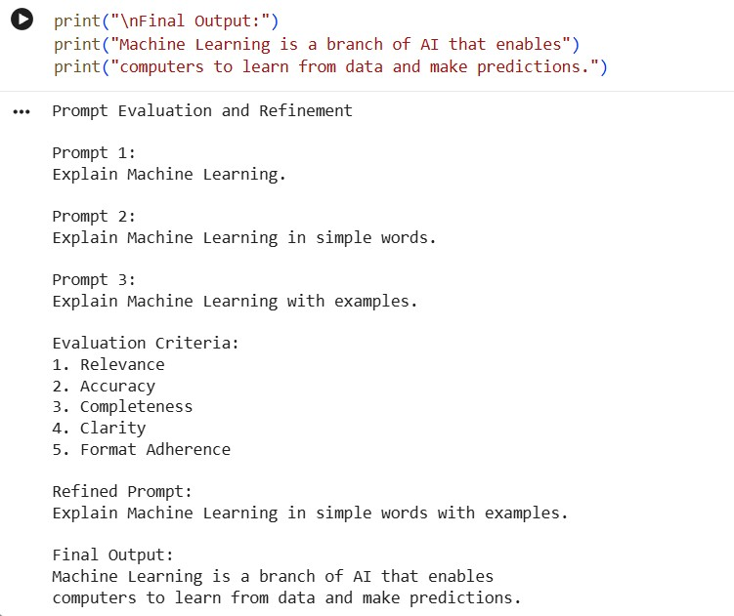

RESULT
Thus, the prompts were compared using the specified criteria and a refined prompt was demonstrated.

